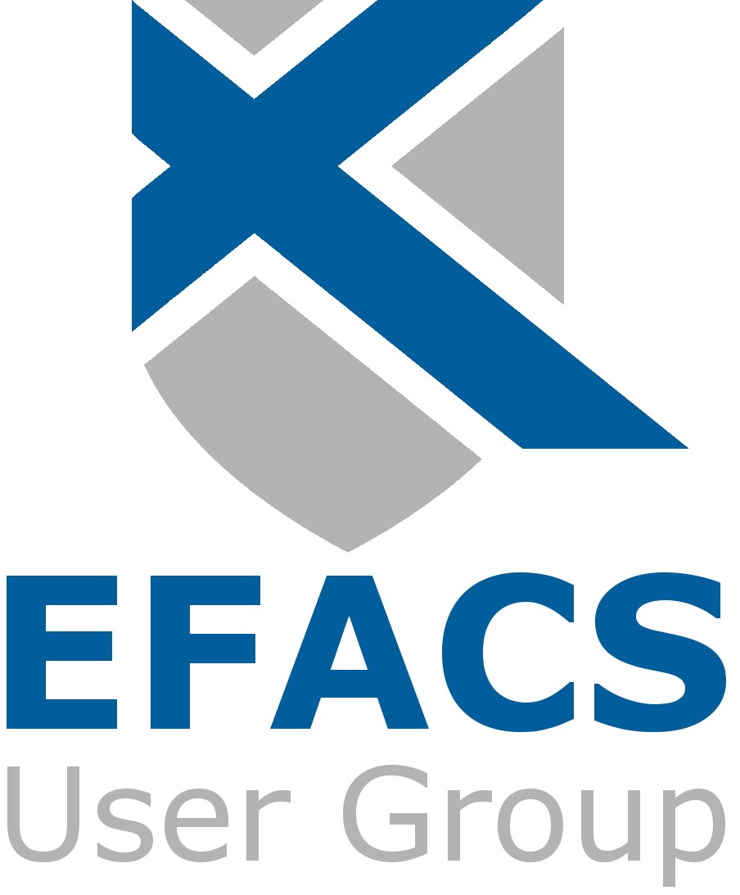
EFACS USER GROUP MEMBERSHIP 2025
INVOICE

Invoice date: Tuesday, 28 July 2026

Subscription for 2025 annual User Group membership.

Amount due (zero rate VAT): £300.00

All payments must be made EXCLUSIVELY to: The EFACS User Group

Please pay via BACS if possible to:

NATWEST
SORT CODE: 60-80-09
ACCOUNT No: 36034762

If paying direct to bank please send remittance advice to the address listed below.

_______________________________________________________________________________________

REMITTANCE ADVICE Detach and return with payment

Please return to:
The EFACS User Group
C/O Exel Computer Systems plc Bothe Hall
Sawley
Nottingham UK
NG10 3XL
Please complete this section with your company details:

Company Name:

Address:

Main Contact Name:

